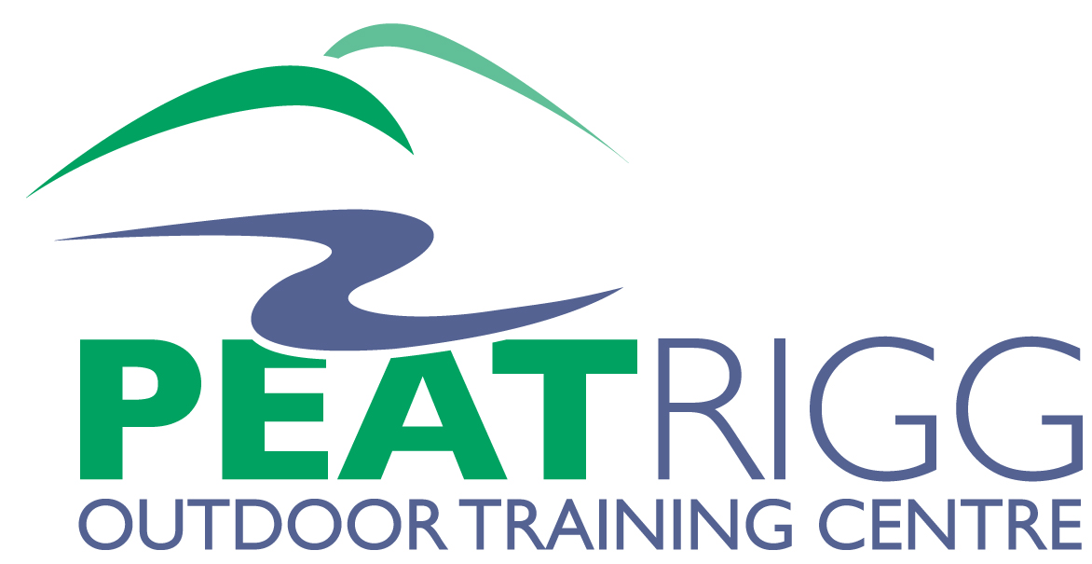

Consent Form
All sections must be completed and the form signed by the parent/guardian of the participant unless participant is over 18 years.

School/Group:
From: Date/time To: Date/time

Personal Information of Participant
Name: Male / Female
Date of Birth: Age:
Address:

Emergency Contact Name: Relationship:
Address:

Emergency Contact Tel Nos:
Medical information

Delete as appropriate

- Does participant have a medical condition of which we should be aware? YES / NO
If YES, please give details:
- Is participant currently receiving medical treatment or medication? YES / NO
If YES, please give details:
- Has participant had surgery within the past year? YES / NO
If YES, please give details:
- Does the participant suffer from epilepsy? YES / NO
If YES, please give details of severity and frequency:
- To the best of your knowledge, has the participant been in contact with any contagious or infectious diseases or suffered from anything in the last four weeks that may be contagious or infectious? YES / NO
If YES, please give details:
GP’s Name: Tel No:
Address:

I will inform the Group Leader/Head Teacher as soon as possible of any changes in the medical or other circumstances between now and the commencement of the residential.

Participant Name:
School/Group: Date of Visit

Other relevant information

- Does participant have any allergies? YES / NO
- Does participant have any specific dietary requirements? YES / NO
If YES, please give details:
- Details of swimming ability: Delete as appropriate None / Average / Confident
- Any other relevant information:

Consent

- I agree to (participant name) taking part in this residential.
- I agree to the above named person participating in a range of activities. Further information on www.peatrigg.org
- Peat Rigg has extremely high standards of quality and safety. However, outdoor activities by their
nature do contain some risk and all course participants should be aware of this. Risk Assessments
are continually reviewed and procedures revised if necessary.
- I acknowledge the need for the above named to behave responsibly and safely at all times.
- I agree to my son/daughter receiving medication as instructed and any emergency dental, medical or surgical treatment, including anaesthetic or blood transfusion, as considered necessary by the medical authorities present.
- Peat Rigg holds Public and Product, and Employer Liability (for £5 million and £10 million respectively). If you wish to hold cover for personal baggage, cancellation etc you should arrange this separately.

Signed by Participant Date:

Signed by Parent/Guardian Date:

Full name of Parent/Guardian
Please note

Often during the course of events photographic material is collected of the young people involved in the activities. In order to safeguard young people at risk please tick this box if you do not wish any photographic material of the above named to be used for promotional/advertisement purposes.

